Monday, May 25, 2020

Having just completed the first successful transition test flight, now we get to explore that (fixed-wing) part of the flight envelope.

Flight 28: Trying out manual fixed wing mode

This flight went great. The aircraft handled the switch back and forth between stabilized and manual modes with no problem. Some basic stats:

Duration: 3:24
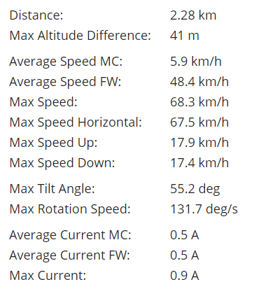

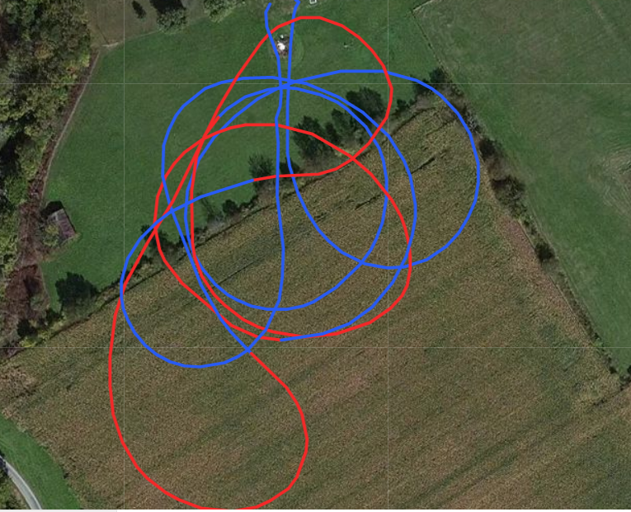
Flight path data. Blue is stabilized mode, red is manual mode.

Tomorrow I will:
- Look at the energy consumption from this flight and get a rough power consumption figure for fixed-wing flight.
- I noticed during both flights (especially this one) that the aircraft is not reaching sufficient speed before completing the transition, so I need to increase the timer for open-loop transition testing.

Side notes:
- I plan to use my rpm sensors with estimations of aircraft velocity to estimate thrust, drag, and aerodynamic performance. This would probably be better with an airspeed sensor, but could be made to work with groundspeed in calm conditions.
- In log 4, I mentioned the possibility of working towards demonstrating fully autonomous VTOL missions. This may require an airspeed sensor.
- I should re-calibrate my ESC’s. Right now the front motors spin up at different levels in fixed-wing mode. It’s unclear whether this is also a problem in MC mode.

Tuesday, May 26, 2020

After making some modifications, I got my arduino nano reading the two hobbywing rpm sensors simultaneously. With an Adafruit breakout board I purchased, I can now output that data (along with the time stamp) to a micro SD card. I am aware that vibration can be a problem for SD cards on flight vehicles, but this is not flight-critical data whatsoever. As of right now, it does not create a new file each time it starts. It uses the same file each time, so I will have to empty the file each time I use it. I admit this could be a pain.

I stayed up late slimming the electrical assembly so that it’s less of a mess of spaghetti. There’s still some wires sticking up, however, and it could easily lead to an in-flight failure of the data-logging. But again, it’s absolutely not flight-critical.

Wednesday, May 27, 2020

This evening I integrated the nano, SD card reader, and rpm sensors on the aircraft. The system is wired to the aircraft’s 5V power system provided by the ESC’s. As of right now, I have one sensor wired to the front right motor and the second wired to back right motor.

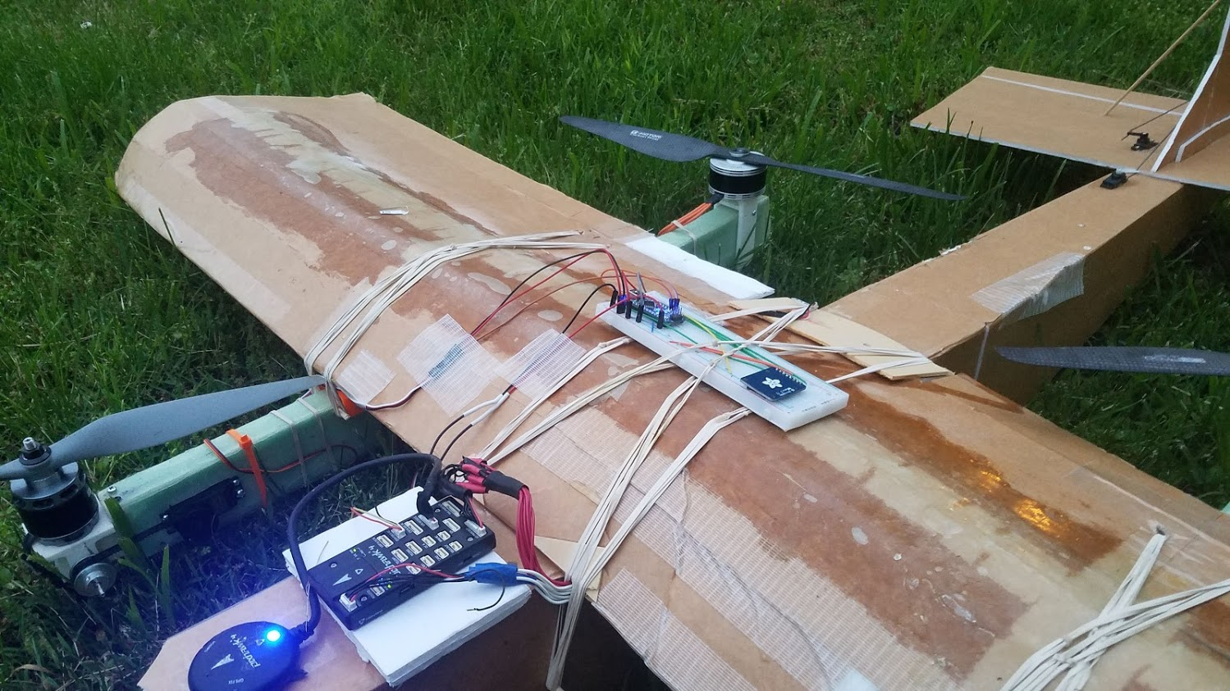

On the right side of the image, you can see my arduino nano and SD card reader used for reading and saving the processed RPM signal from the “rpm sensors.”

I changed VT_F_TR_OL_TM from 4 seconds to 5 seconds because the transition last time was a little scary (because the airplane was not quite up to speed yet).

Flight 29:

Quick hover flight in my back yard

Flight 30:

Another quick hover flight

Flight 31:

This was an very short hop to try proving the sensors (and data logging) again. Once again, no forward motor data.

“Flight” 32:

Not really a flight or even a hop. I just wanted to spin up the motors to test the rpm sensor again. Again, no forward motor data.

After looking this more closely with a multimeter, I found what seems like a bad solder joint between one of the motor wires and the wire that connects it to the rpm sensor. Fixing this should fix the sensor.

May 28, 2020

I fixed the solder joint and tested it with a multimeter. For whatever reason I could not get a good solder joint with the motor wire, so I instead soldered the lead to the ESC side. It’s possible that motor wire has some sort of coating or something. This new configuration will make things weird if I ever want to unplug these, but I can deal with that later.

I tested the system, and it looks like it works now.

Flight 33:

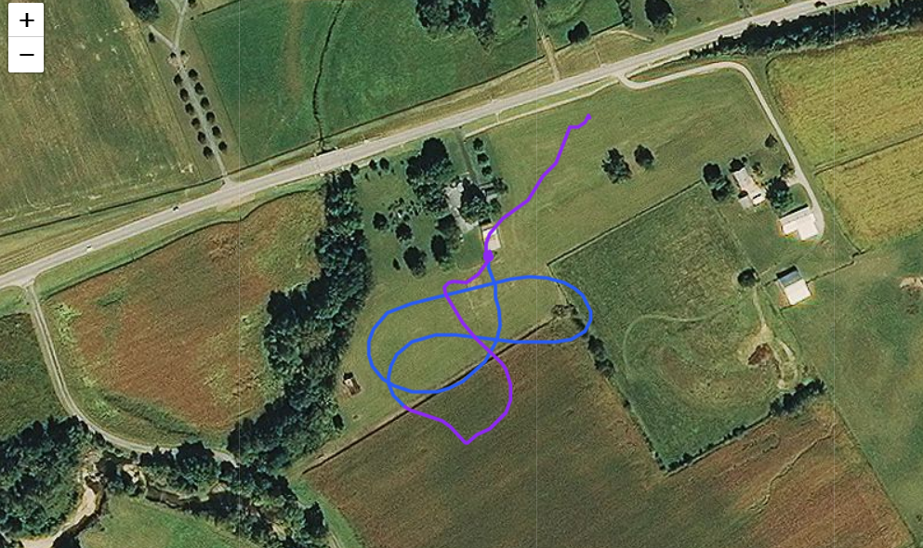

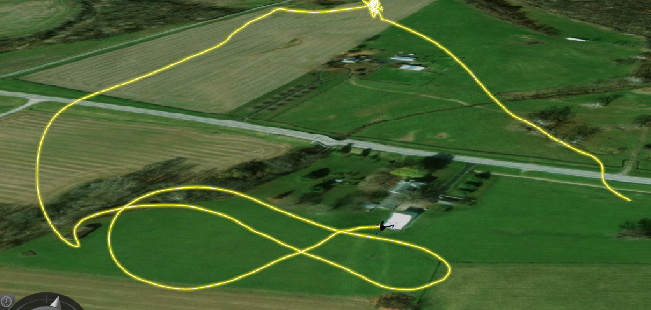
3d-view of the aircraft’s flight path. Notice on the left, where the aircraft aggressively climbs to an altitude of 100+m before switching to MC mode and hovering at ~100m.

Okay, so this was EXCITING. Yeah, so I crashed the airplane. Funny enough, it once again did a pretty good job saving itself. Unfortunately, a few settings were set poorly.

The aircraft took off successfully and did a successful transition. Everything was hunky dory until it suddenly pitched up, throttled up, and climbed at a vertical rate of about 34 km/h (vertical!). The aircraft leveled out at about 110 meters and transitioned back into hover mode directly over our heads. I recognized this as a communication lost return mode. The only problem is it never landed. It maintained altitude and position surprisingly well, but it simply loitered until the battery was completely dead. On the way down, it mostly maintained attitude control and finally hit the ground relatively softly.

Things I learned:
- I’m surprised that the vehicle flew autonomously as well as it did. It even successfully did an inbound transition autonomously! This also re-proved that I can fly an autonomous VTOL transition without an airspeed sensor. So really this accomplished a few risky test points that I wanted to explore in the future.
- Wow, that plane can climb quickly. It might not be a bad idea to decrease the max autonomous climb rate setting. Strangely enough, according to the computer, FW_T_CLIMB_MAX is set to 5 m/s. The data looks like it climbed at about 9 m/s.
- Okay, so the position hold mode works pretty well right now. While it’s true that it’s hard to be sure the of the aircraft’s exact position, it visually looked like it had wandered above my head. The data, however, says that the aircraft was hovering over the position where I powered it on. That’s what I would have expected.
- I decreased the return-to-land altitude from 100m to 60m. It will fly back to the landing site and then descend from 60m to 30m. After waiting 30 seconds, it will start to slowly descend until it lands. On one hand, I want to make sure the aircraft doesn’t hit a tree or something while loitering/returning-to-land, but also 100 meters is very high. Making the aircraft climb to that altitude in this setting is probably not necessary. Also, it’s possible that I would have regained radio control if it were hovering at a low altitude.
- Turns out that the RTL_LAND_DELAY setting was set to -1. This value means that it will not return to land. It simply hovers over the home point, like it did this time. I’m assuming that it is waiting to regain radio contact. In this case it ran out of batteries. I’m changing the value to 30 s. This is the duration at which it will loiter at 30m if it loses connection again.

Like I said, the aircraft will be pretty easy to repair… The battery is another story. It’s puffed up, warm, and generally unhappy. I need to decide how to proceed. I probably shouldn’t keep using this battery. This plane already pushes it pretty hard, but this was bad. Instead of hovering for ~3 minutes, I flew for 8 minutes and most of it was hovering. It literally fell out of the sky. I’m interested in moving to a 6S power system, as an investment for future platforms, but I question whether that’s feasible right now. The current aircraft flies well with a 5S battery, and I worry that 6S would be too much for this airframe. I’ll look into whether the pixhawk can set motor throttle limiters. If you can, it might help control the system despite being significantly overpowered.

For some reason, my arduino/rpm sensor system did not record all the rpm data. Instead, it only recorded one data point. I suspect this might have to do with it creating a new file. I think i’ve seen a bug where if I power up the system and there is not an existing Datalog0 file in the drive, it only records the first data point. I need to do more testing to confirm this.

Monday, June 1, 2020

I had to re-build the inner portion of the aileron, re-glue the motor-arm mounting. I will point out that I have now repaired both ailerons in the exact same way after crashes. Also the left motor motor mounting

Good news: I did a range check with my transmitter and another receiver I have, and there were no issues. I’m assuming that means my transmitter is in good shape.
Bad news: I did a range check with my transmitter and this aircraft, and it did not work. The aircraft had a loss-of-signal and (I’m assuming) went into autonomous mode. This was on the ground and the motors disarmed, so there was no risk to the aircraft.

I also did a quick run-up test to make sure the RPM sensor was working. It was. Hopefully that won’t change for the upcoming flight.

Flight Goal: After the aircraft did a return last time, I want to do one intentionally to make sure it works. This is especially because I just changed some settings. Also, I just set the RTL_RETURN_ALT parameter to 50m (from 60m) for this test.

I also set RTL_LAND_DELAY from 30s to 15s for this test flight. I want to keep this flight short.

For the sake of simplicity, I will do this first test starting in hover mode. I also need to very careful where I power on the aircraft…. I don’t want it autonomously landing into a tree or a building.

If it goes well, I’ll be able to try a VTOL RTL at a later date. Though I probably should fix the receiver issue first.

This time, I will start the return mode with a switch (rather than loss-of signal). Hopefully.

Flight 34:

Okay, this was a disaster. I positioned the aircraft facing North(ish) so that when doing the return-to-launch, it could simply fly back towards the landing site and set down. I was not sure if the aircraft would try to assume the yaw orientation at launch, but I figured it was a possibility.

Shortly after takeoff, I was turning to the left so I could fly out over the field. That’s where I was going to hit the return switch. Instead, as it was turning, the aircraft started to sink and just fell out of the sky. I had tried to increase the throttle, but it kept falling.

At first I attributed this to pilot error. I assumed that because the aircraft was yawing pretty hard, it was probably seeing a net loss in max thrust (because two motors were speeding down).

I have RPM data from this flight. (see below)

Flight 35:

Second try. Similar result. The plane sank out of the sky.

I still thought this was likely because the aircraft was yawing. I figured that because I was yawing to the left, it could be fighting the tendency to turn right that results from the twist in the wing.

I have RPM data from this flight. It’s on the same file as the data from flight 34.

Flight 36:

This time I faced the aircraft ~East, but the result was similar. After turning (right) south and flying over the field, I noticed the aircraft losing power. Finally, it sank into the long grass. At this point it was obvious that my battery was shot. This isn’t really a surprise.

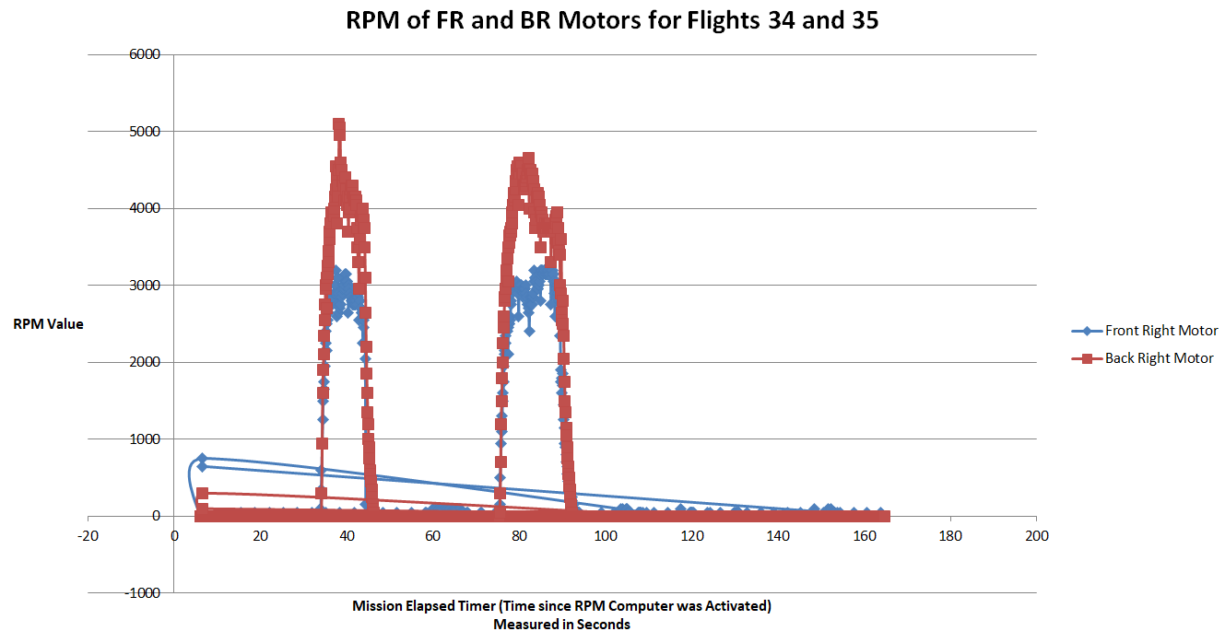

I did some basic analysis on the RPM data from flights 34 and 35. Eyeballing it based on the graph, it looks like the right-front motor averaged ~2900 RPM and the aft-right motor averaged around ~4150. Assuming it is accurate, according to APC and T-Motor propeller data, that corresponds to ~1 lb and ~3.19 lbs, respectively. That’s a huge difference. In theory, that means that the front left motor would have to be producing about 3.19 lbs, and the back left motor would be producing about 1 lb of thrust. Based on these assumptions, that implies a liftoff thrust of ~8.4 lbs. At last measure, the plane had grown to about 9.35 lbs. These motors are almost perfectly centered over the center-of-gravity, so this difference in thrust must be explained by a large yaw control input.

It is worth noting that in both of these flights, I did take off and turn to the left. This is consistent with the data. The back right motor spins CW, so if the right aft motor is speeding up to maintain yaw control in a hover.... Well then the aircraft would have a tendency to turn CCW (left).

Also, the horrible twist in the wing (and therefore the positioning of the motors) should (for the aircraft in a hover) cause it to want to yaw cw (to the right).

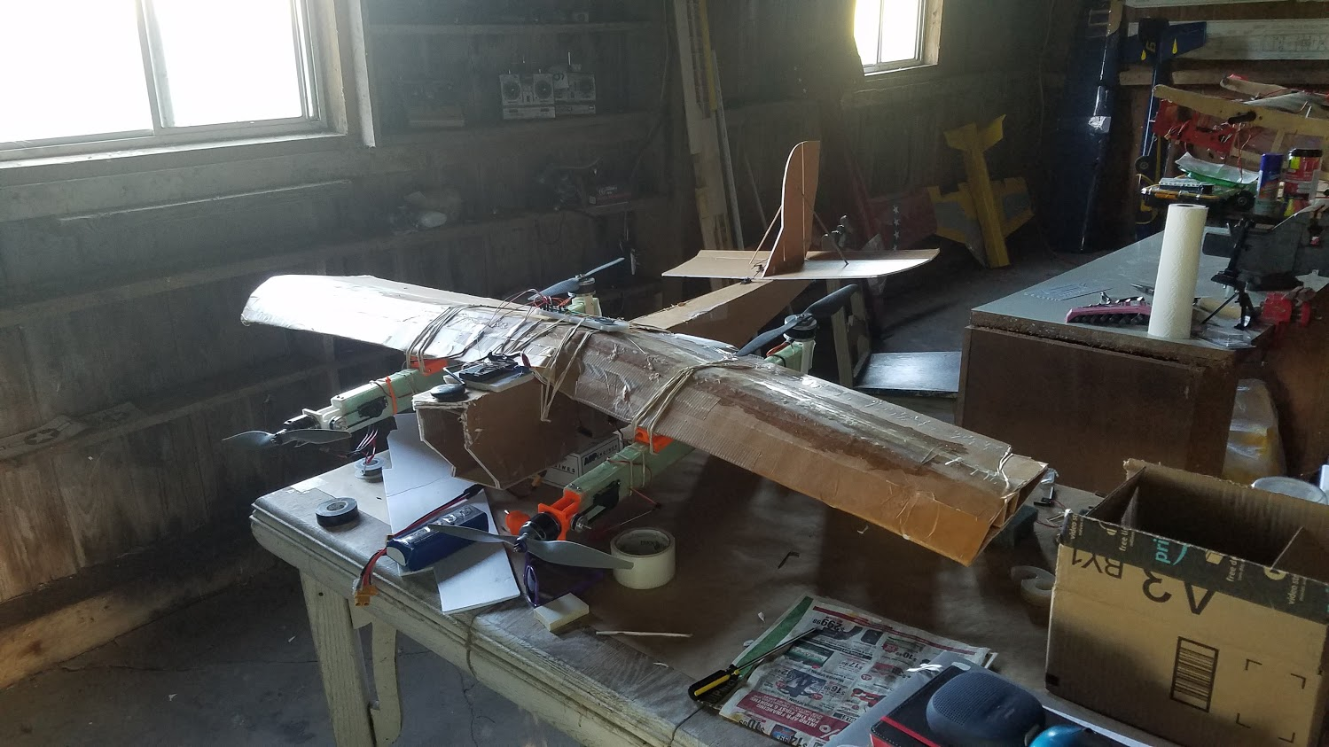
In this picture, you can see where the left wing is starting to collapse structurally. This is causing the left motor arm to pitch downward and, as the data would suggest, a right-ward yaw moment.

It is worth pointing out, however, that these “eyeballed” average are pretty constant throughout the flight. This suggests that the aircraft is mostly yawing so hard to fight the warp in the wing, because that is constant.

Final thoughts:
Remarkably, I had a “working” airplane one day, and one with many problems the next. Summarizing, here’s the current status:
- My Satellite receiver doesn’t give full range and good connectivity. Not sure if that’s by design or fault. I need to research this more. There’s solutions to this, but I’m not sure which one I like yet. Plus they require money.
- Airframe is quickly falling apart and is essentially on its last leg. That is, unless I decide to do heavy repair work (or a full rebuild) on the main wing.
- My 5S lipo battery is destroyed, and I don’t really want to buy a new one. I’m not certain that I’m in the mood to splurge on a 6S lipo right now either.
- I accidentally demonstrated some autonomous flight capability on this aircraft...enough to make me a lot less nervous if I move to testing on a more high-value aircraft. Also, as a side note, I recently did an autonomous pixhawk flight on a different airplane and it went fine.
- It is worth noting that the motor-pivot belts did sometimes slip, but rarely in-flight. It is, of course, absolutely necessary that the system is well-tensioned.

I think Igloo VTOL is essentially done, and has mostly served its purpose. At least for now. The only outstanding thing I would be very interested in testing would be fixed-wing active yaw stabilization--esp with split spoilerons or other drag brakes. That was a target that I wanted to work on. The other thing is I never got to confirm power consumption or propeller performance for fixed-wing flight.

I could still move on to the high-performance iterations I’ve envisioned, but I’m not quite sure that’s what I should spend my time, money, and energies on. Or I could work on testing with Muse (If I could my hands on the outer-wing panels), but I still think that seems sub-optimal.

